CIS 111 Week 14 Part 2 Assignment Schedule
Excel, Access, HTML Discovering Computers, important info Exams, quizzes Hyperlinks Due Dates
Date | Topic |  | Assignments | Due Dates
Week 14  Part 2  begins  FRIDAY,  Nov. 29.  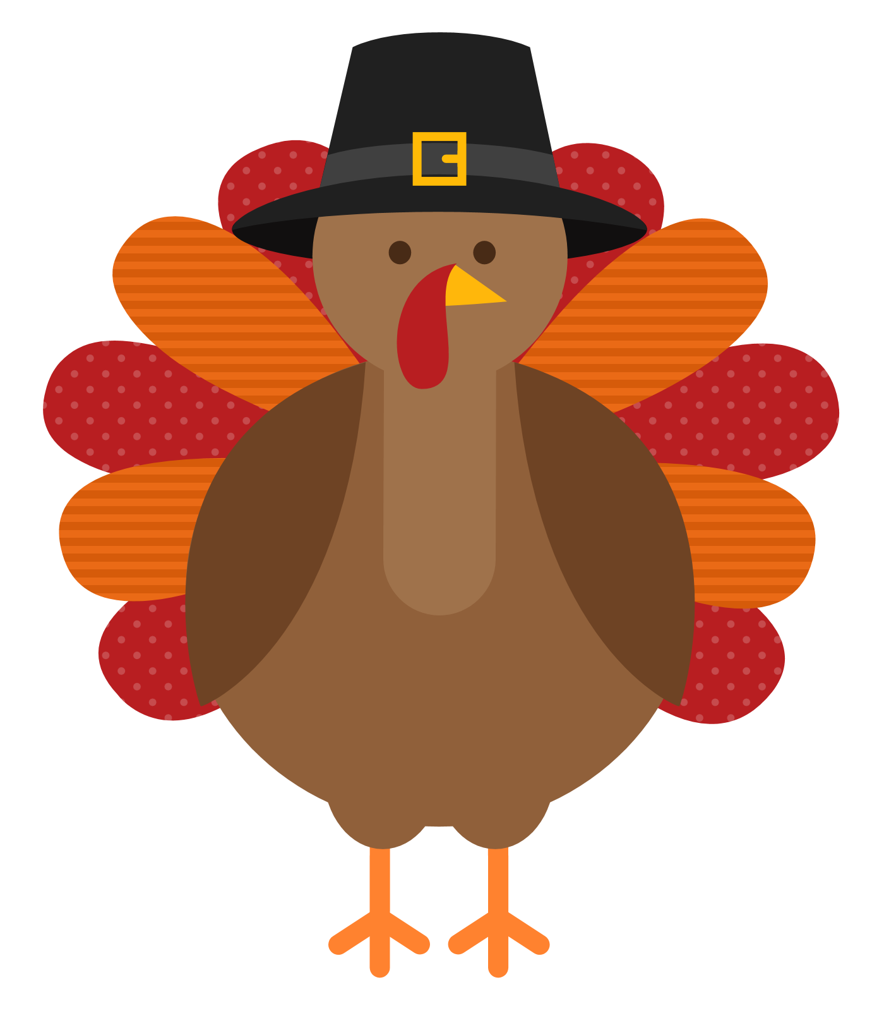  Happy Thanksgiving | 1. Use weekly checklist  2. Download folders  3. Word –  Module 3  Formatting Text & Graphics  4. SAM Training  5. SAM Project  6. SAM Practice Exam for MS Word  7. SAM ‘Real’ Exam for MS Word  8. Watch videos  9. DC Ch 12  10. SAM DC Quiz – Chapter 12  11. FYI | ☐  ☐  ☐  ☐  ☐  ☐  ☐  ☐  ☐  ☐  ☐  ☐  ☐  ☐  ☐  ☐  ☐ | -Use checklist to keep track of your completed assignments.  -If you run into problems, post your questions on the blog.  -Always do assignments in the order listed below.  -Download Word 3 folder from Watson’s Website. Unzip & label folder, CRN# firstname lastname Word Module 3.  NOTE: There is an ebook in SAM with chapter material for the Word chapters. The SAM Training, Projects, and Exams are related to the chapters in the ebook.  -FYI: Additional online help from Microsoft: Microsoft Training for Word  -If needed, use the Illustrated Collection Microsoft Office 365 & Office 2019 ebook in SAM for Word Module 3 chapter for detailed Word instruction to help with the Word project below.  -SAM Training for Word Module 3 – Complete the SAM training assignment before attempting the SAM project assignment.  -SAM Project for Word Module 3. Download instruction file, start file, and any supplemental files if applicable.  -Follow downloaded instructions to complete the project.  -Upload finished project to SAM for grading.  -Save project file in Word folder.  -SAM Word Module 3 practice exam is not required but strongly recommended.  -SAM REAL Exam for Word Module 3.  -What is Information Systems?  -What is data mining?  -What is informatics? (UCI has this major.)  -Read DC Module 12, “Information System Development”.  -Complete the SAM DC Quiz 12. THIS IS THE LAST DC QUIZ.  -What is SalesForce?  (Salesforce helps everyone in your company work more productively and better deliver the personalized experiences customers love. Employers often want potential employees to know how to use SalesForce.) | Please do not wait until the last minute to do your SAM assignments. Murphy’s Law: What can go wrong, will go wrong.  ☐ Submit Word Module 3 folder by dragging into shared Google Drive folder, “Drag Folders Here” Tuesday, Dec. 3, 11:59pm.  ☐ All SAM assignments for Word due Tuesday, Dec. 3, 11:59pm.  ☐ Complete DC Ch 12 reading before Quiz 12.  ☐ SAM Quiz for DC Ch 12 by Tuesday, Dec. 3, 11:59pm.
 | 12. Blog & Gmail | ☐  ☐ | -Check your personal email 3 to 4 times throughout the week.  -Read class blog 3 to 4 times throughout the week.

