CIS 111 Week 14 Part 1 Assignment Schedule
Excel, Access, HTML Discovering Computers, important info Exams, quizzes Hyperlinks Due Dates
Date | Topic |  | Assignments | Due Dates
Week 14  Part 1  begins Monday,  Nov. 25.  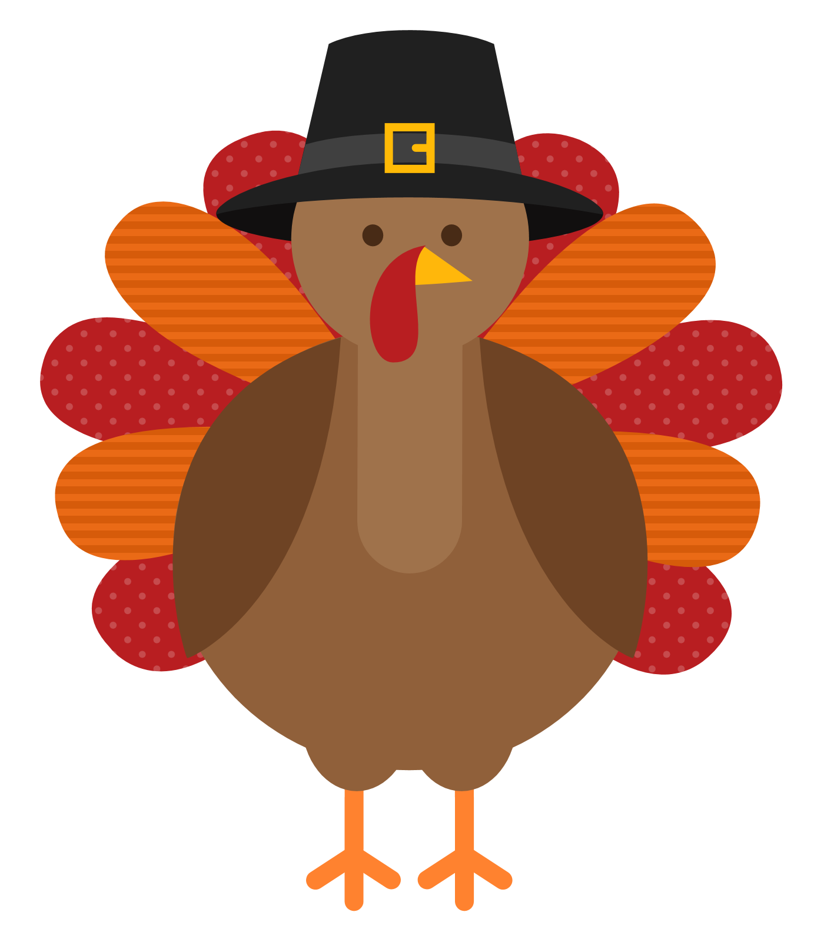  Happy Thanksgiving | 1. Use weekly checklist  2. Download folders  3. Word –  Module 2  Editing and Formatting Documents  4. SAM Training  5. SAM Project  6. SAM Practice Exam for MS Word  7. SAM ‘Real’ Exam for MS Word | ☐  ☐  ☐  ☐  ☐  ☐  ☐  ☐  ☐  ☐  ☐  ☐  ☐ | -Use checklist to keep track of your completed assignments.  -If you run into problems, post your questions on the blog.  -Always do assignments in the order listed below.  -Download Word Module 2 folder from Watson’s Website. Unzip & label folder, CRN# firstname lastname Word Module 2.  NOTE: There is an ebook in SAM with chapter material for Word & PPTX. The SAM Training, Projects, and Exams are related to the chapters in the ebook.  -FYI: Additional online help from Microsoft: Microsoft Training for Word  -In SAM, there is an ebook, Illustrated Collection Microsoft Office 365 & Office 2019. If needed, use the ebook in SAM for Word Module 2 chapter for detailed Word instruction to help with the Word project below.  -SAM Training for Word Module 2 – Complete the SAM training assignment before attempting the SAM project assignment.  -SAM Project for Word Module 2. Download instruction file, start file, and any supplemental files if applicable.  -Follow downloaded instructions to complete the project.  -Upload finished project to SAM for grading.  -Save project file in Word folder.  - SAM Word Module 2 practice exam is not required but strongly recommended. Practice exams are available for 49 tries.  -SAM REAL Exam for Word Module 2. Unlike practice exams, you get only one try on ‘real’ exams. | Please do not wait until the last minute to do your SAM assignments. Murphy’s Law: What can go wrong, will go wrong.  ☐ Submit Word Module 2 folder by dragging into shared Google Drive folder, “Drag Folders Here” WEDNESDAY, Nov. 27, 11:59pm.  ☐ All SAM assignments for Word Module 2 due WEDNESDAY, Nov. 27, 11:59pm.

